ALBOS UK Web design flow

1. **Goal identification**: Where I work with the client to determine what goals the new website needs to fulfill. I.e., what its purpose is.
2. **Scope definition**: Once we know the site's goals, we can define the scope of the project. I.e., what web pages and features the site requires to fulfill the goal, and the timeline for building those out.
3. **Sitemap and wireframe creation**: With the scope well-defined, we can start digging into the sitemap, defining how the content and features we defined in scope definition will interrelate.
4. **Testing on a group of 3 users of youth mental health services**

**Goal:** Make a website for youth mental health services.

**Scope definition:** Pages:

* Landing
* Our Work
* Get Involved
* Who we are

**Competitor Analysis:**

What he likes about Able Child

* navbar: Finds immersion from transparent to sticky w/white background on scroll
* sections are clear and easy to read, not too much info. Likes the key info highlighted
* Bold vibe

What he likes about smk

* The colour co-ordination
* Clear mission, stoyline-like

**Stepped-section wireframing:**

Here’s the final wireframe paired with the refined result for each section, BEFORE user testing:

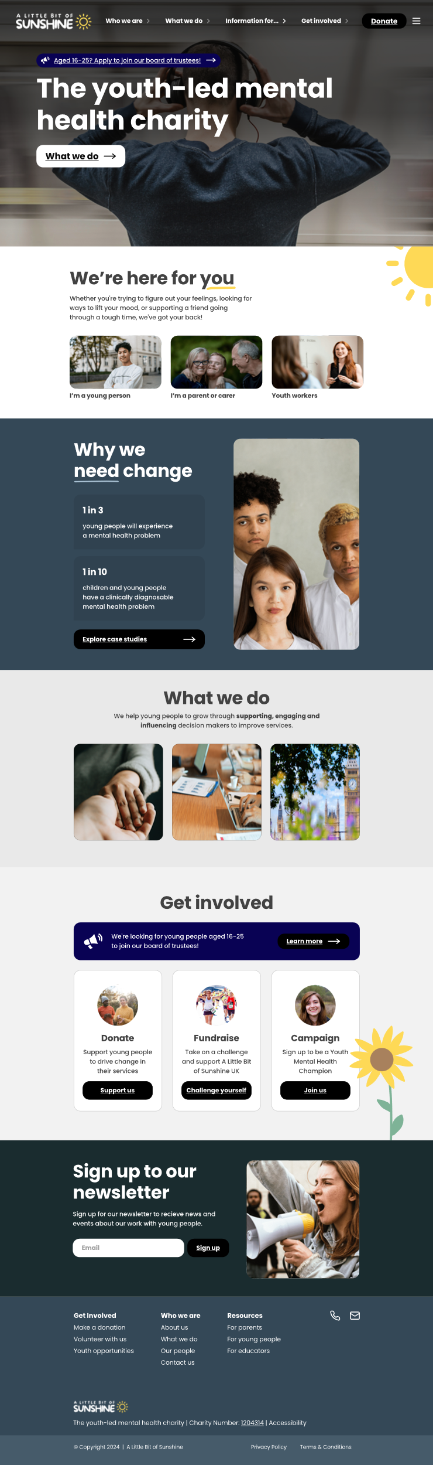

**User testing:**

We have a focus group of 3 young people who are users of online mental health services.

person 1:

ABC

person 2:

DEF

Person 3:

GHI

Here’s the write-up of the call

person 1: I think abc

person 2: def could be changed based on ghi

Summary:

67% of users found abc difficult to read

Call on 26/06: Go in depth regarding goal. What’s the exact goal for:

* young people?
* parent/carers?
* educators?